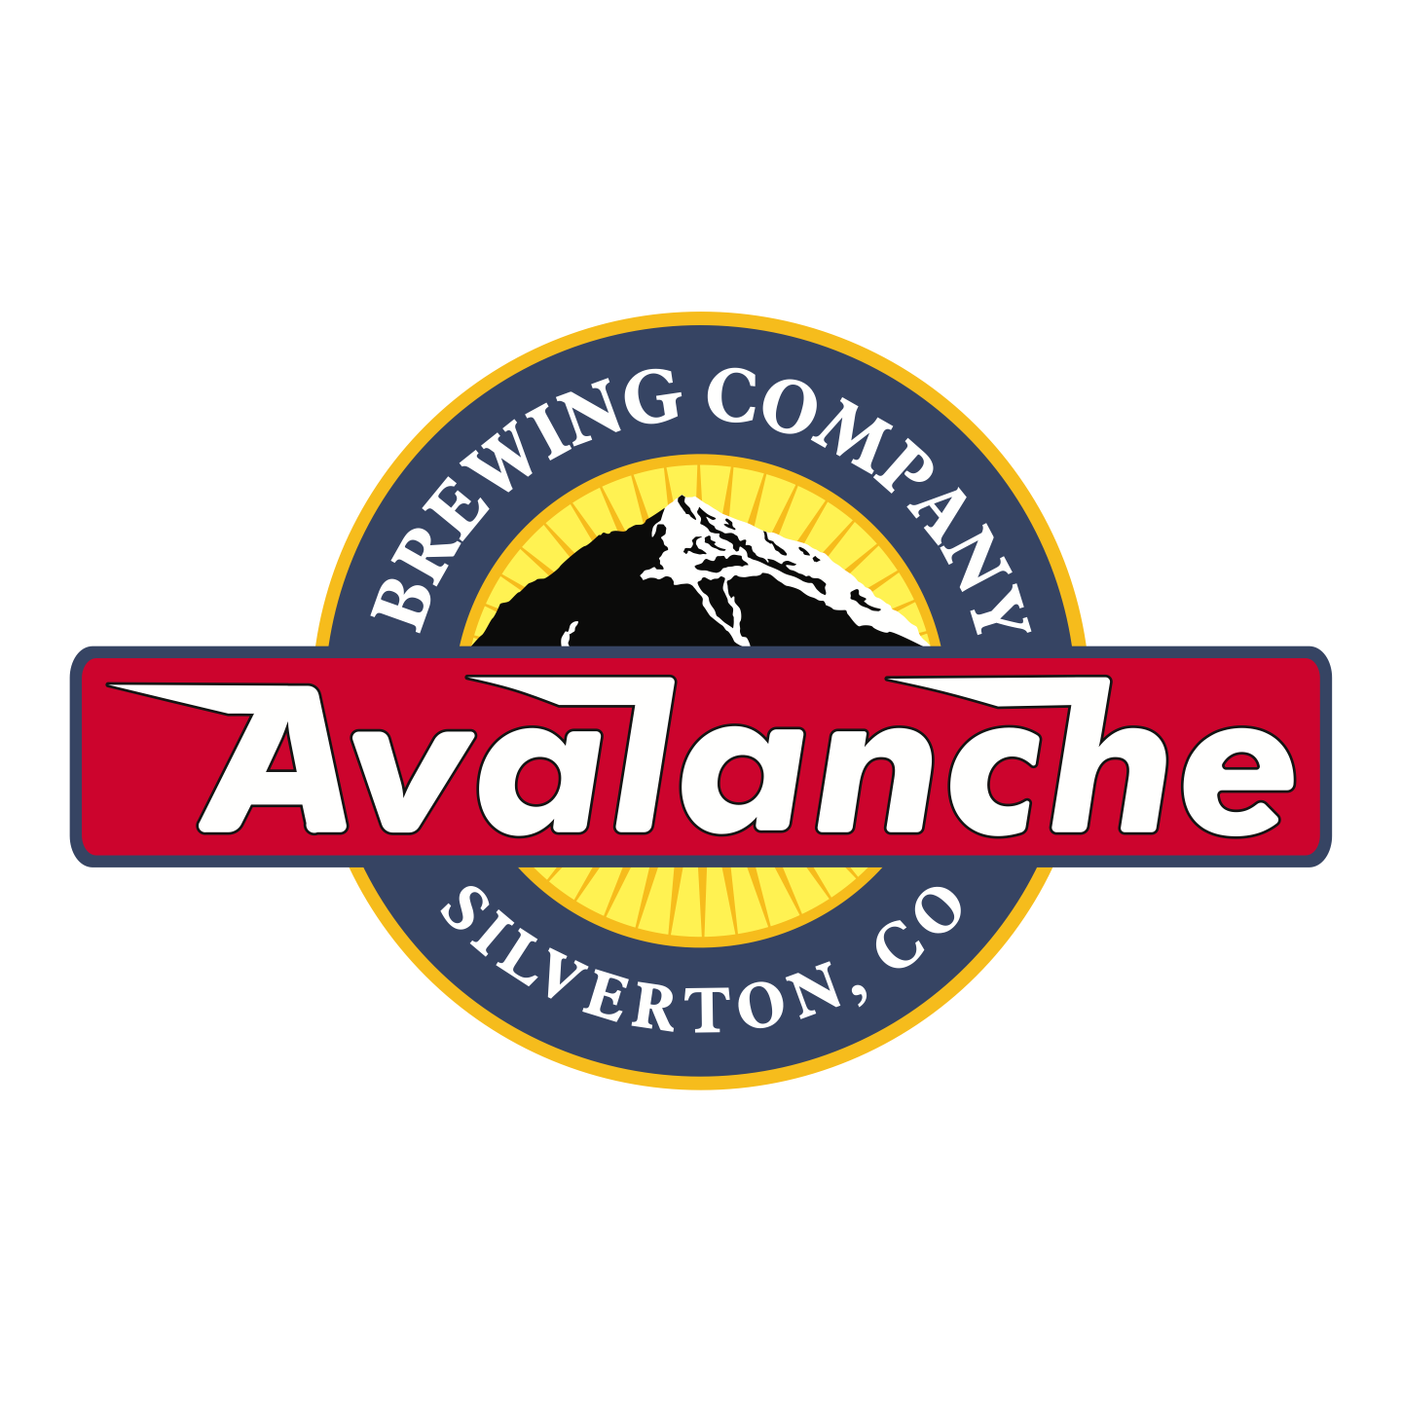

Avalanche Brewing Company

P.O Box 377, Silverton, CO 81433

970-387-5282

[avalanchebrewing@gmail.com](mailto:avalanchebrewing@gmail.com)

Donation Request

Avalanche Brewing Company is proud to support our local community and non-profit organizations. Before requesting a donation please read through the information about our companies policy regarding donations. A copy of your organizations IRS Determination Letter and/or your Special Events Alcohol Permit are **required.** Please complete this form and return it to us by mail or email at least 14 days prior to your event for us to consider for our donation quota.

Name of Event:

Non-Profit Organization:

Non-Profit Number:

ABC Permit Number:

Contact Name:

Phone:

Email:

Mailing Address:

Address of Event:

Date of Event:

Description of Event:

Estimated Attendance:

Other Micro-Breweries Represented?:

Type of Donation Requested:

Will you need tapping Equipment?

How many?

Need a tub?

How many?

If requesting alcohol must be 21 years or older.

Who is picking up the product and equipment?

When will you be picking up your donation?

Other Comments:

Signature of Organization Event Coordinator:__________________________

Avalanche Brewing Staff Only:

Date request was received:

Donation approved by: